DIS-POINTS-Beaver4 Lake

2 9/16" long Beaver Lake point

From: Barren Co., Kentucky

Material: an attractive multicolored grey flint material

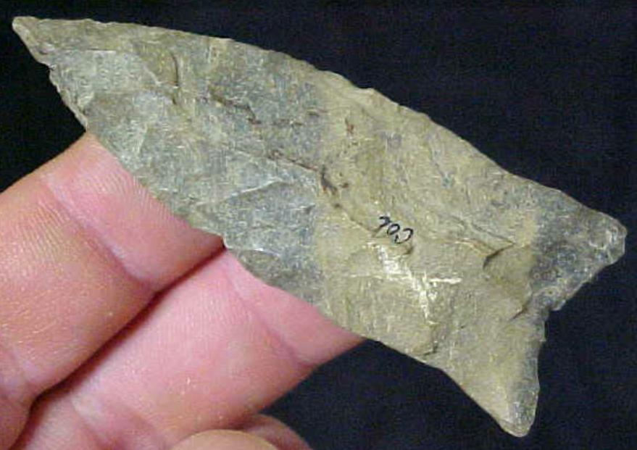 SHAPE \* MERGEFORMAT 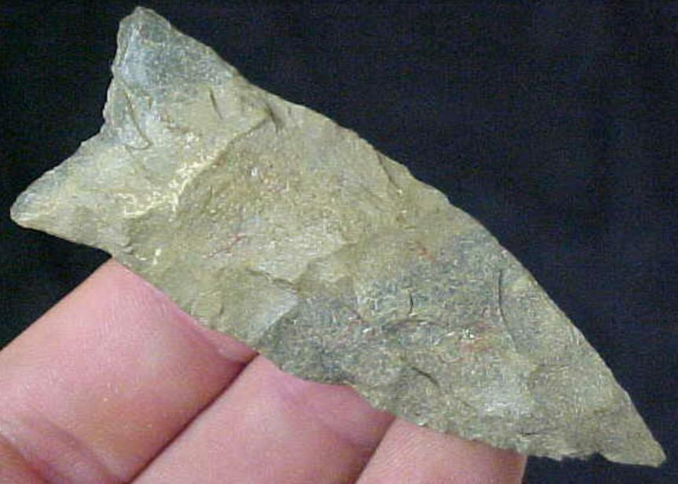

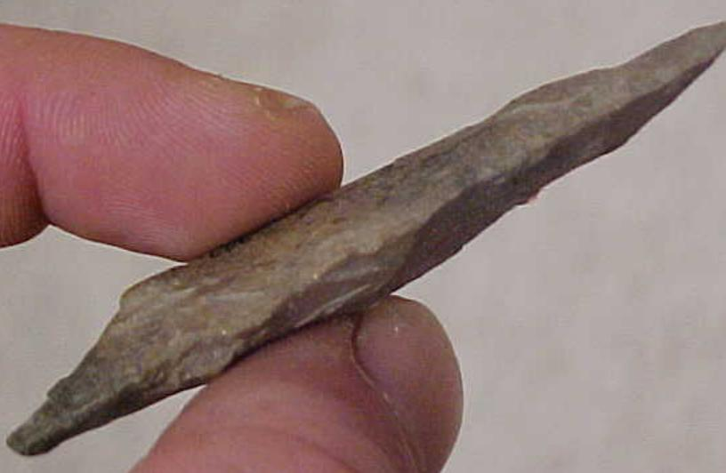

Sold by [mydirtyolboots](http://myworld.ebay.com/mydirtyolboots) ( [5346](http://feedback.ebay.com/ws/eBayISAPI.dll?ViewFeedback&userid=mydirtyolboots) )

### Delivery package 1 of 1

Delivered on Monday, Sep 28, 2015

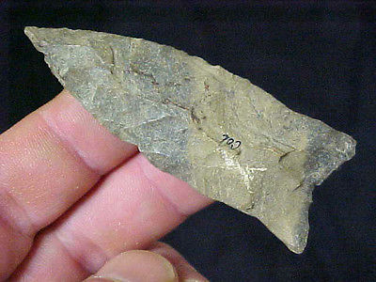

#### [RARE KENTUCKY PALEO BEAVER LAKE POINT Arrowhead Authentic Artifact A12](http://www.ebay.com/itm/141775683478)

|  |  |
| --- | --- |
| Item price | $45.44 |
| Quantity | 1 |
| Item number | 141775683478 |
| Shipping service | USPS First Class Package |